**CHAPTER 1**

**INTRODUCTION**

* 1. **PROJECT BACKGROUND**

This study is about billing system, a specialized system and hardware solution designed to manage and streamline various aspects of the billing, ordering, and payment processes within a coffee shop. It serves as the central point for handling customer orders, ensuring accurate billing, and facilitating smooth transactions. This shop often require an efficient and effective billing system to manage orders and process transactions accurately.

This study conducted in 1128 Tea & Café located at 70 Kalusugan St. Batasan Hills, Quezon City owned by Mr. Jonathan Gorillo Golo.

**1.1.1 Problem Opportunity / Description**

**1.1.1.1 Slow Checkout Process**

Long wait times to pay the bill, especially during busy hours, can be an issue that affects the customer's experience.

**1.1.1.2 Difficulty in Custom Orders and Special Requests**

The client difficulty handling customizations in invoicing the order of customer.

**1.1.1.3 Inaccurate Cash Handling and Change Calculations**

These issues can cause errors, produce improper to manage the cash and inaccurate change processing of cash transactions

**1.1.2 Benefits**

**1.1.2.1 Shop Owner**

This system can benefit the shop owner by improving its operations, streamlining operations, increasing sales, enhance customer service, and improve efficiency.

**1.1.2.2 Customers**

They can benefit from a smooth and efficient ordering and payment process, reducing waiting times and enhancing their overall experience.

**1.1.2.3 Staff and Employees**

Staff can benefit from a simplified workflow that reduces the likelihood of order errors and allows them to focus on providing quality service.

**1.1.2.4 Future Researchers**

Researcher play an important part that benefit the development and advancement of numerous fields, by expanding our knowledge, solving problems, enchanting decision-making, and educating future generations.

**1.1.3 Goals**

**1.1.3.1** To provide login form for the security of data.

**1.1.3.2** To provide dashboard to easily navigate the system.

**1.1.3.3** To provide service quality to perceive a 89 expectations of a service with in order performance.

**1.1.3.4** To provide quality product to insure to the satisfaction of the customers that purchasing the brand of the product, able to encourage them to buy the products and increase the revenue.

**1.1.3.5** To provide invoice that process a charges a customers for goods or service, and such able to show all the information about a transaction.

**1.1.3.7** To provide serving a proper delivery of a product from the customers.

**1.1.3.8** To be able speed up the customer payments.

**1.1.3.9** To be able sales report it help to provide evaluate sales performance, analyze the sales and record of all sales activity taking place within a company over a certain period of time.

**1.1.3.10** To provide purchasing of a product at the right price and quality.

**1.1.3.11** To be able on receiving or collecting payment from the customers after the orders are given to customers.

* 1. **PROJECT SCOPE**

This project scope aims about billing system that maintain the collecting payments, invoices, and prices from the shop, we include to the website by conducting order database from the admin, ordering page for delivery platform, and menu for choosing a flavor, add quantity, sugar level, add-ons, checkout, checkout complete, and the background information to the coffee shop.

**1.2.1 Objectives**

**1.2.1.1 Fast checkout process**

It maintains the accuracy of shopping experience that allows to complete their purchases quickly and efficiently, it is possible to minimize the time to complete the transaction.

**1.2.1.2 Customize orders and special request**

This is provide personalized products or services to the client, by personalizing the purchases according to their unique needs and additional services beyond what is typically offered.

**1.2.1.3 Accurate cash handling and change calculations**

It is safekeeping of cash to ensure that all financial transactions are conducted, this include using secure safes or cash register, preparing correct change using counting cash, calculating the amount accurately.

**1.2.2 Project Deliverables / Work Products Description**

**1.2.2.1 Objective 1: Fast checkout process**

|  |  |
| --- | --- |
| **Project Deliverables** | **Work Products/Description** |
| **Digital Payment** | The payment is a transfer of money, goods, or services in exchange for a product or service, this include using cash, credit card, checks, and digital payments that able to transact. |
| **Order Management** | It refers to the process of a client purchasing a product, it is required to deliver the products as specified in the client’s purchase. |

**Table 1: Objective 1**

**1.2.2.2 Objective 2: Customize orders and special request**

|  |  |
| --- | --- |
| **Project Deliverables** | **Work Products/Description** |
| **Customization** | It is personal preference by the client, the modification can be applied option to make their own add to the design, flavor and feature to the product. |
| **Menu** | This provide a list of food and drinks offered to customers and the prices, which presents a list of options from the customers choose. |

**Table 2: Objective 2**

**1.2.2.3 Objective 3: Accurate cash handling and change calculations**

|  |  |
| --- | --- |
| **Project Deliverables** | **Work Products/Description** |
| **Calculator** | It is a device used to perform mathematical calculations used for various purposes including basic arithmetic operations such as addition, subtraction, multiplication it helps maintaining accurate records of transaction, this is essential for calculating the total amount of purchases. |
| **Security** | It is encompasses measures and protocols put in place to safeguard against potential threats and risks, it also includes cash handling procedures to helps minimize the risk of errors or intentional miscue of funds. |

**Table 3: Objective 3**

**1.2.3 Out of Scope**

**1.2.3.1 Statistics of an salary**

This feature is not stable from creating a system, our topic is to gain a smooth flow of ordering and payments process as a manual from the shop.

**.2.3.3 Checks**

As a manual the shop is doesn’t have a check, but the shop have a database who have to purchase the product the date, time, flavor, pay and name of the customer has visible to see.

**1.2.3.5 Barcode on the product**

The coffee shop doesn’t have a barcode due to the managing process from the shop ordering and paying the product, the barcode is not allowed since to the manual transaction.

**1.3 PROJECT PLAN**

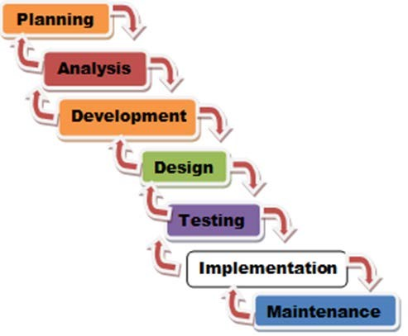**1.3.1 Approach and Methodology**

**Figure 1: Waterfall Model (SDLC)**

**1.3.1.1 Planning**

This provide process of conducting by brainstorming, researching, thinking of the title, that manages by project manager who responsible for planning the system and assisting by the staffs.

**1.3.1.2 Analysis**

The client was suggested by business analyst, we gain information and conducting a interview to the client regarding about the billing system, that aimed as manual, transaction, payment, invoicing.

**1.3.1.3 Development**

This provide a growth and to make a progress by conducting a study regarding to the system, we have to reached the deepest part of the research to gain a much clearer study, writing codes for the program of the website, gain a knowledge from the study conducting a research.

**1.3.1.4 Design**

This is the process of a thinking that identify what themed for creating the website, by assisting of the system analyst to gain a fitter design for creating website.

**1.3.1.5 Testing**

This provide by programmer that writing code, using visual studio, writing code for creating the website, and assisting by the system analyst to insure the design is working.

**1.3.1.6 Implementation**

This provide processing of design, developing, testing and deploying a software or hardware, to meet the specific need to solve a particular problem from the study, preparing and careful research to the system to achieve clearly documentation and gain a smooth programming.

**1.3.1.7 Maintenance**

This refers to support the study and address different issues and needs ensuring the smooth functioning of a system, by assisting of the project manager and other staffs to maintain the accuracy doing creating the system.

**1.3.2 Project Timeline**

|  |  |  |  |  |
| --- | --- | --- | --- | --- |
| **ID** | **Task Name** | **Start** | **Finish** | **Duration** |
| 1 | Forming group | September 14,2023 | September 27,2023 | 13 days |
| 2 | Brainstorming | September 28,2023 | September 29,2023 | 1 day |
| 3 | Creating a final system | October 3,2023 | October 4,2023 | 1 day |
| 4 | Assigning roles | October 18,2023 | October 19,2023 | 1 day |
| 5 | Finding client | December 16,2023 | December 17,2023 | 1 day |
| 6 | Request an endorsement latter | January 3,2024 | January 4,2024 | 1 day |
| 7 | Creating questionnaires | January 8,2024 | January 9,2024 | 1 day |
| 8 | Setting up an interview | January 8,2024 | January 9,2023 | 1 day |
| 9 | Doing project timeline | October 29,2023 | November 2,2023 | 4 days |
| 10 | Doing problem Opportunity/Description | October 29,2023 | November 2,2023 | 4 days |
| 11 | Doing benefits | October 29,2023 | October 2,2024 | 4 days |
| 12 | Setting goals | October 29,2023 | November 2,2023 | 4 days |
| 13 | Doing project scope | January 4,2024 | January 5,2024 | 1 day |
| 14 | Setting objective | January 5,2024 | January 6,2024 | 1 day |
| 15 | Doing project in Deliverables/work Description | January 5,2024 | January 6,2024 | 1 day |
| 16 | Doing out scope | January 16,2024 | January 17,2024 | 1 day |
| 17 | Setting project scope | January 6,2024 | January 7,2024 | 1 day |
| 18 | Doing project plan | January 11,2024 | January 12,2024 | 1 day |
| 19 | Doing project timeline | January 16,2024 | January 17,2024 | 1 day |
| 20 | Doing issues policy complication | January 12,2024 | January 13,2024 | 1 day |
| 21 | Setting risk management | January 13,2024 | January 14,2024 | 1 day |
| 22 | Doing service transition | January 13,2024 | January 14,2024 | 1 day |
| 23 | Doing technical feature | January 14,2024 | January 15,2024 | 1 day |
| 24 | Doing project organization and staffing | January 14,2024 | January 15,2024 | 1 day |
| 25 | Setting project budget | January 13,2024 | January 14,2024 | 1 day |
| 26 | Finding local studies | January 4,2024 | January 16,2024 | 13 days |
| 27 | Finding foreign studies | January 4,2024 | January 7,2024 | 4 days |
| 28 | Doing related literature | January 16,2024 | January 17,2024 | 1 day |
| 29 | Doing synthesis and relevance to the study  (Comparative analysis) | January 16,2024 | January 17,2024 | 1 day |
| 30 | Doing conceptual frame work | January 16,2024 | January 17,2024 | 1 day |
| 31 | Doing flowchart of the system | January 16,2024 | January 17,2024 | 1 day |
| 32 | Setting power point presentation | January 16,2024 | January 17,2024 | 1 day |
| 33 | Pre-oral defense | January 17,2024 | January 17,2024 | 6 hours |
| 34 | Doing dedication | March, 04,2024 | March 06,2024 | 3 days |
| 35 | Doing project and system requirements | March 29,2024 | March 31,2024 | 3 days |
| 36 | Doing test results and discussions | March 29,2024 | March 31,2024 | 3 days |
| 37 | Doing conclusion and recommendation | March 29,2024 | March 31,2024 | 3 days |
| 38 | Appendices | March 29,2024 | March 31,2024 | 3 days |
| 39 | Preparing mock defense | April 8,2024 | April 8,2024 | 6 hours |
| 39 | Final defense | April 15,2025 | April 15,2024 | 6 hours |

**Table 4: Project Timeline**

**1.3.3 Issues Policy Implications**

**1.3.3.1 Plagiarism**

This issue is considered a violation, presenting work or ideas from another source as your own, with or without consent of the original author.

**1.3.3.2 Customer Rights/Customer Protection Act**

This issue against unfair practices in the coffee shop or any other marketplace, the customer’s right to be informed about their data processing, access their personal information, request correction of inaccuracies, and object to processing under specific circumstances.

**1.3.3.3 Data Privacy**

This act protects the privacy of individuals and ensures \that their personal information is collected, processed and disclosed in a lawful and responsible manner.

**1.3.3.4 Copy Right**

It is role in protecting intellectual property rights and fostering creativity by providing creator with legal protections and incentives to produce new works.

**1.3.4 Risk Management Plan**

|  |  |  |  |
| --- | --- | --- | --- |
| **Risk Factor** | **Probability**  **(H – M - L)** | **Impact**  **(H – M - L)** | **Risk Management Action** |
| Virus | H | H | Install antivirus that can detect and remove computer viruses and malware in real time. |
| Blackout | M | M | Prepare battery, install a backup power source, such as generator, to ensure that essential system remain operational during power outages. |
| Data breach | H | H | Implement continuous monitoring of network traffic, system logs, and user activities to detect any anomalous behavior. indicative of a potential breach. |
| Hacking | H | H | Ensure the security of the data requires a compilation of strong passwords, two-factor authentication, keeping your software and devices up to date, being cautious of phishing attempts, using VPN, educating your self and others, and reporting suspicious activity. |

**Table 5: Risk Management Plan**

**1.3.5 Service Transition**

**1.3.5.1 Training / Seminar**

It is individual and organizational growth, offer numerous benefits, such as skill development, networking opportunities, and personal growth, by attending workshops, courses, and conferences, professionals can stay updated with the latest industry trends and best practices.

**1.3.5.2 User Manual**

It is a comprehensive document that provides instructions, guidance, and information on the proper use, installation, maintenance, and troubleshooting of a specific product or system. It serves as a vital resource for users to understand the features, functionalities, and limitations of a product, ensuring optimal performance and user satisfaction.

**1.3.5.3 Initial Meeting**

This provide open communication, active listening, and a positive attitude throughout the meeting to ensure a successful outcome.

**1.3.5.4 Client feedback**

It is process of gathering information, opinions, and evaluations from clients about the products, services, or overall experience they receive from a business or service provider.

**1.4 TECHNICAL FEATURES**

**1.4.1 Hardware**

|  |  |
| --- | --- |
| **Hardware** | **Description** |
| Laptop | It is a personal computer, is a compact, lightweight, and versatile device for various computing tasks. |
| Computer | It is a perform a wide range of tasks, to their ability to execute instructions and manipulate data. |
| Wi-Fi Router | This provide internet connection, it allows multiple devices, such as computers, smartphones, tablets, and smart home devices, to connect to the internet at the same time without need for physical. |
| Printer | This It allows multiple devices, such as computers, smartphones, tablets, and smart home devices, to connect to the internet. |

**Table 6: Hardware**

**1.4.1 Software**

|  |  |
| --- | --- |
| **Software** | **Description** |
| Visual Studio Code | It is a software application source code editor that is well-suited for developers working with a wide range of programming languages and technologies. |
| Microsoft Word | It is a word processing program developed by microsoft, it’s processing application that provides essential tools for creating and formatting various tupes of documents. |
| XAMPP | It is a code editor that is well-suited for developers working with a wide range of programming languages and technologies, the process of setting up a local testing environment and allows them to work on their projects without relying on a remote server. |
| MySQL | It is an open-source relational database management system, that is widely used for managing and storing data in various applications, SQL language offers a range of features, such as transactions, security, and scalability, to ensure the efficient management and protection of data. |

**Table 7: Software**

**1.5 PROJECT ORGANIZATION AND STAFFING**

|  |  |  |  |
| --- | --- | --- | --- |
| **Role** | **Name and Contact Information** | **Responsibilities** | **Time** |
| Project Manager | Drixx Iver C. Agravante  0910 614 3694  [drixxiveragravante@gmail.com](mailto:drixxiveragravante@gmail.com) | This person is responsible for the planning, procurement, execution and completion of a project and the process of leading the work of the team. | Anytime |
| Programmer | Justine Kyle Ola  0930 186 7107  [kyleola07@gmail.com](mailto:kyleola07@gmail.com) | This person is responsible for the program codes. Programmer is a crucial role in software development, whether it is creating application, websites, games, or any other type of software they write codes, test it, debug errors, and often collaborate with other members of a development team. | Anytime |
| System Analyst | Jester Gonzaga  0938 249 0396  [jestergonzaga0988@gmail.com](mailto:jestergonzaga0988@gmail.com)  Jude belgar bande  0960 447 8553  judebande217@gmail.com | This person is responsible in analyzing, designing, and implementing information system. They play a crucial role in bringing the gap between business needs and technology solutions. | Anytime |
| Business Analyst | Jhon Rafael L. Isanan  0905 244 6024  [jhonisanan24@gmail.com](mailto:jhonisanan24@gmail.com) | This person is responsible in dealing with works with an organization to identify, analyze, and solve business problems. They bridge the gap between business needs and technology solutions, helping to improve processes, products, services, and software applications. | Anytime |
| Documentation Specialist | John Mark C. Elieza  09455018987  [Johnmarkelieza159@gmail.com](mailto:Johnmarkelieza159@gmail.com) | This person is responsible for specializes in creating, organizing, and managing various types of documents, have primary role is accessible, and well-structured for affective communication and reference. | Anytime |

**Table 8: Project Organization and Staffing**

**1.6 PROJECT BUDGET**

|  |  |  |
| --- | --- | --- |
| **Budget Item** | **Description** | **Budgeted Cost** |
| Laptop | Device that used in creating the documentation and creating codes for the study. | Php 30, 000.00 |
| Smart Phone | Device that used in online communication using group chat for the study. | Php 9, 000.00 |
| Tablet | device that used in creating the documentation and using research for the study. | Php 7, 000.00 |
| Computer | Device that used into creating codes for the study. | Php 55,000.00 |
| Foods | It serves as a source of energy and nutrients required for the body’s growth, development, and maintenance. | Php 1, 500.00 |
| Transportation | This essential to able transport the people and goods from one place to another. | Php 1, 860.00 |
|  |  |  |
| **Total Cost** | | Php 101,000.00 |

**Table 9: Project Budget**

**1.7 RELATED LITERATURE AND STUDIES**

**1.7.1 Local Study**

**1.7.1.1 Assessment of Electronic Payment Platforms Adoption and Perceive of Local Coffee Shops in Poblacion, Cauayan City, Isabela**

According to M.J Salvador et al.(2023) The COVID-19 pandemic has had a significant impact on micro business ventures in Cauayan City, Isabela, Philippines due to their limited resources and vulnerability to external shocks. Electronic payment platforms have revolutionized the local coffee shops scene, leading to increased digital transactions and economic benefits for the city. The study employed a mixed-method research design. Respondents strongly agreed on the usefulness, ease of use and user acceptance of electronic payments.

Source:https://www.researchgate.net/publication/371575062_ASSESSMENT_OF_ELECTRONIC_PAYMENT_PLATFORMS_ADOPTION_AND_PERCEIVED_BENEFITS_OF_LOCAL_COFFEE_SHOPS_IN_POBLACION_CAUAYAN_CITY_ISABELA_PHILIPPINES

# **1.7.1.2 Analysis and Design of Enterprise Resource Planning System for a Coffee Shop**

This study J.C Arroyo.,(2020).In the past few decades, process automation has been an increasing trend in businesses seeking to increase operational efficiency and improve customer experience by streamlining their processes. However, Koffie Pauze, a local coffee shop in Davao City, Philippines, has not been benefiting much from this information technology revolution, which results in a setback on its productivity, profitability, and competitive advantage. This paper is structured as a software development project for Koffie Pauze to deliver a solution through an Enterprise Resource Planning (ERP) system, which covers automation of their existing processes in Point-of-Sales (POS), kitchen, loyalty and rewards, and network management for their employees and customers. To improve customer experience, a self-service kiosk is introduced to the business environment and as well as a "Grab-and-Go" scheme of purchasing goods through a mobile application for on-the-go customers. The primary focus of this paper is to provide stakeholders detailed documentation on the planning, development, testing, implementation, and maintenance of a software solution using V-Model that aims to solve the challenges experienced by the business.

Source:https://www.researchgate.net/publication/342625577_Analysis_and_Design_of_Enterprise_Resource_Planning_System_for_a_Coffee_Shop

# **1.7.1.3 Feasibility Study On Establishing Coffee Shop.**

According to M.J, Doming.,(2019).The Thunder Coffee is envisioned to be the first class coffee shop serving the best coffee in Ilocos Norte. Its mission is to make Thunder Cafë to be competitive and well-known coffee shop in the North. Its objective includes the improvement of quality of life by offering the llocanos employment opportunities. It also aspires to promote the native delicacies of the Ilocanos. In putting up a coffee shop that reflects the culture of Ilocano greatly influenced the student proponents to conduct the aforementioned study. The vending machines and any convenient store in Laoag City can provide coffee but cannot accommodate the increasing number of coffee drinkers. Thus, the Thunder Cafè will surely be the one that will provide the service that they can't get from the said coffee distributors.

Source:https://www.scribd.com/document/445208288/feasibility-study-on-establishing-coffee-shop

**1.7.2 Foreign Study**

**1.7.2.1 Coffee Shop Management System C#**

According to Abhi et al.(2019).Coffee Shop Management System is based on a concept to maintain orders and management of a particular coffee shop. There are two sections in this project, they are Coffee Ordering and Admin panel. By using this system, he/she can maintain ordering records of a day. By selecting Coffee Order the system displays a list of Available coffee drinks and the user has to place an order with item quantity. After that, he/she proceeds towards Order confirmation and Payment methods. Almost 80% of the population are coffee lovers. Coffee Shop Management Systemin C#.NET consists following modules such as; Login Module, Employee Module, Administrator Module. This project is developed in C#.NET using C# language and MicrosoftSQL database used. The role of the administrator is to maintain employee information including operations like modifying, deleting, updating the employee records and customer order records in the system.

Source:https://www.scribd.com/document/435834741/Coffee-shop-management-system-c

**1.7.2.2 Cafe BDU building System**

In the study N.J Akhi, et al.,(2022).Cafe BDU building Systemis web application to restaurant management. This system wakes to provide service facility to the café and to the customer. The services that are provided is food ordering and billing by the customer through the system online, admin information management and staff information management, menu information management and bill management. Main objectives to build this system is to provide ordering and bill service by online to the customer. With this system online, ordering and bill management will become easier and systematic to replace traditional system where paper is used.

Source: https://www.scribd.com/document/586071153/Cafe-Billing-System-Project-Report

**1.7.2.3 Analysis of Point of Sale System Implementation in Coffee Shop**

According to Hidayati, et.al,(2023,june).Analysis of Point of Sale System Implementation in Coffee Shop. Cusses implementing a point of sale (POS) system in a coffee shop business through a case study method and SWOT analysis. The study shows that the performance of a POS system can significantly improve the efficiency and financial management of the company. The POS system can help inventory management, predict customer demand, and avoid excess or shortage of merchandise stock. It can also speed up the customer payment process, improve customer experience, and generate accurate sales reports. The article concludes that implementing a POS system can be an effective solution for coffee shop businesses to optimize their operations and increase profitability, despite facing challenges and obstacles such as high implementation costs and staff training. Therefore, coffee shop businesses should consider implementing a POS system and ensure that it can be integrated with the existing systems of the business.

Source: https://www.scribd.com/document/445208288/feasibility-study-on-establishing-coffee-shop

**1.7.3 Synthesis and Relevance to the study (Comparative Analysis)**

|  |  |  |  |  |  |  |  |
| --- | --- | --- | --- | --- | --- | --- | --- |
| **Project/System Features** | **Local 1** | **Local 2** | **Local 3** | **Foreign 1** | **Foreign 2** | **Foreign 3** | ***Researcher stu*dy** |
| Ordering System |  |  |  |  |  |  |  |
| Login System |  |  |  |  |  |  |  |
| Admin Panel |  |  |  |  |  |  |  |
| Display total Cash and Cash Ttransaction |  |  |  |  |  |  |  |
| Item Counter |  |  |  |  |  |  |  |
| Instant Order Preview |  |  |  |  |  |  |  |
| System Users Administrator |  |  |  |  |  |  |  |
| System Users staff |  |  |  |  |  |  |  |
| Electronic payment |  |  |  |  |  |  |  |
| Point of sale |  |  |  |  |  |  |  |
| Order queuing |  |  |  |  |  |  |  |
| Network management |  |  |  |  |  |  |  |
| Kiosk |  |  |  |  |  |  |  |
| Mobile application |  |  |  |  |  |  |  |
| Delivery |  |  |  |  |  |  |  |
| Quality and packaging |  |  |  |  |  |  |  |
| Washing and sanitizing |  |  |  |  |  |  |  |
| Clearing and cleaning |  |  |  |  |  |  |  |
|  |  |  |  |  |  |  |  |
|  |  |  |  |  |  |  |  |
|  |  |  |  |  |  |  |  |
|  |  |  |  |  |  |  |  |
|  |  |  |  |  |  |  |  |

**Table 10: Comparative Analysis**

**1.8 CONCEPTUAL FRAMEWORK**

**PROCESSS**

**OUTPUT**

**INPUT**

**Figure 2: Conceptual Framework**

**CHAPTER 2**

**PROJECT DEVELOPMENT**

**2.1 DESIGN / LAYOUT**

**2.1.1 For clients**

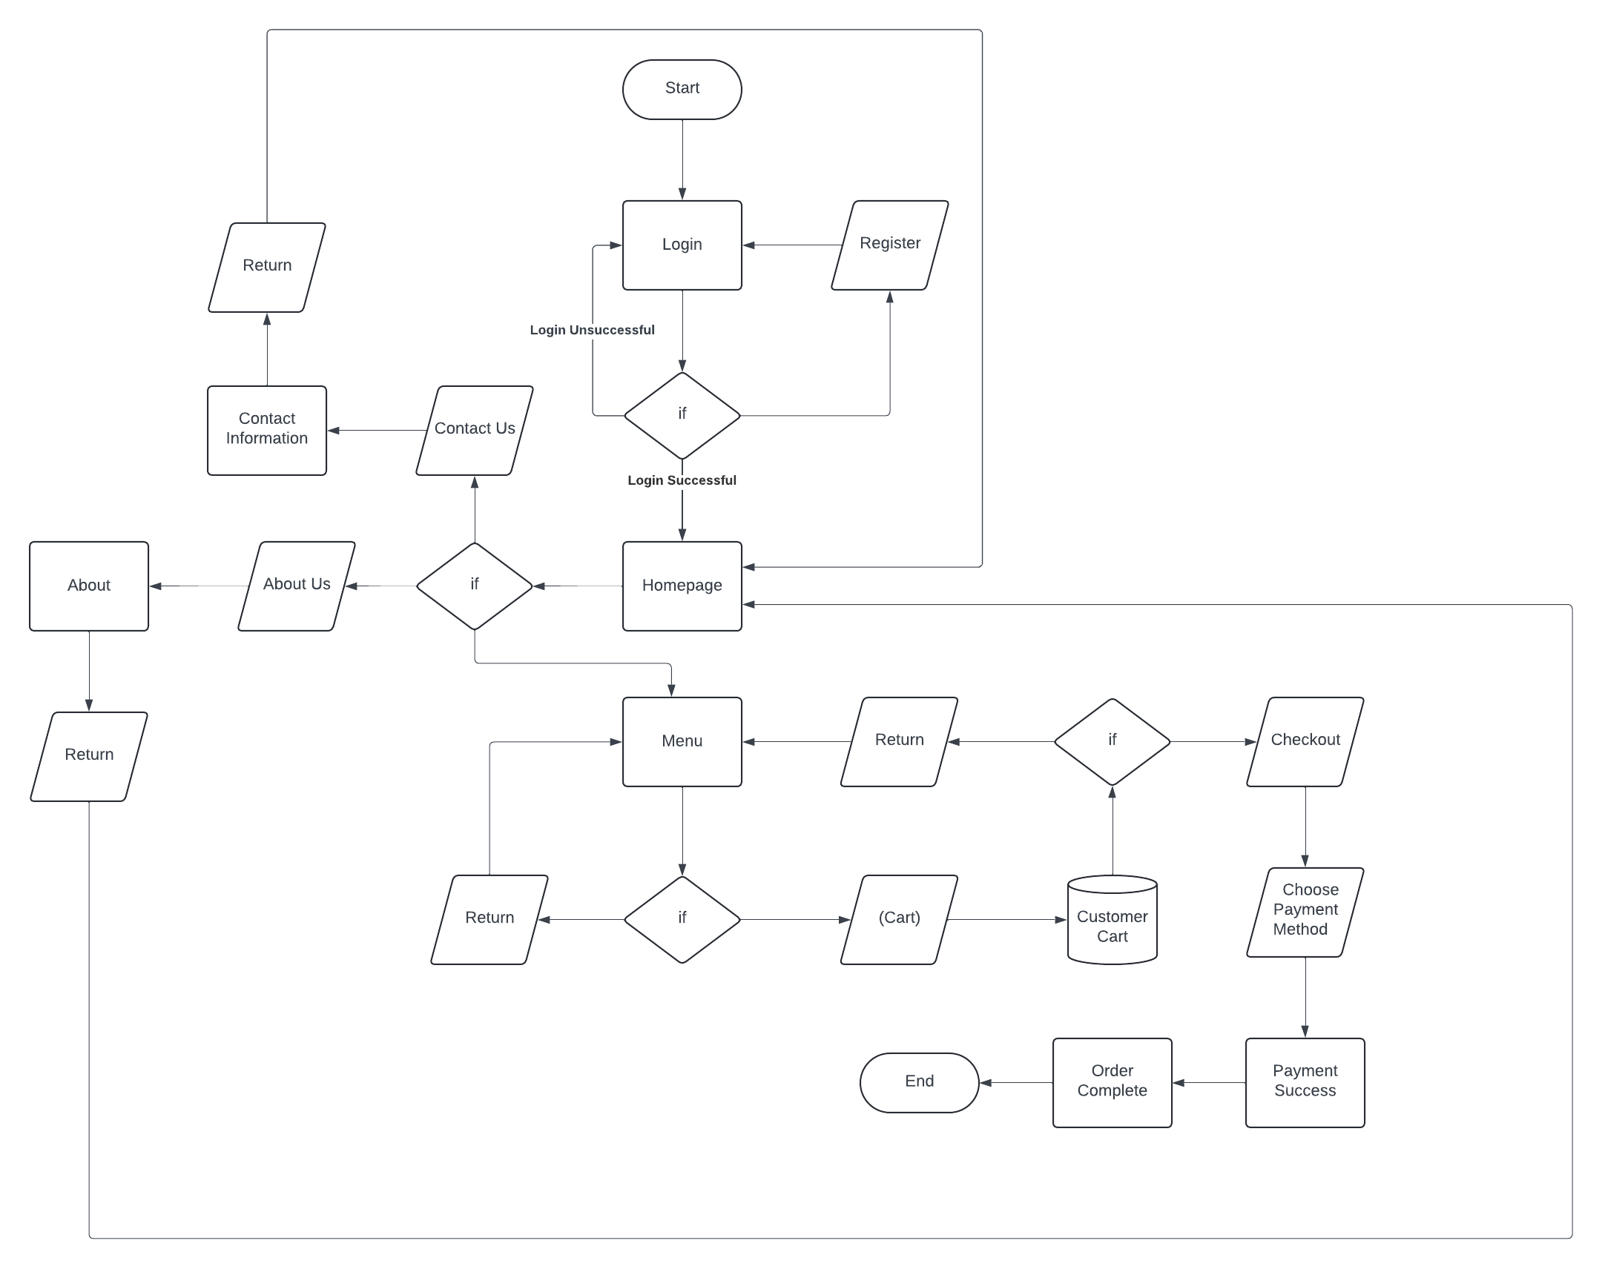

**2.1.2 For Admin**

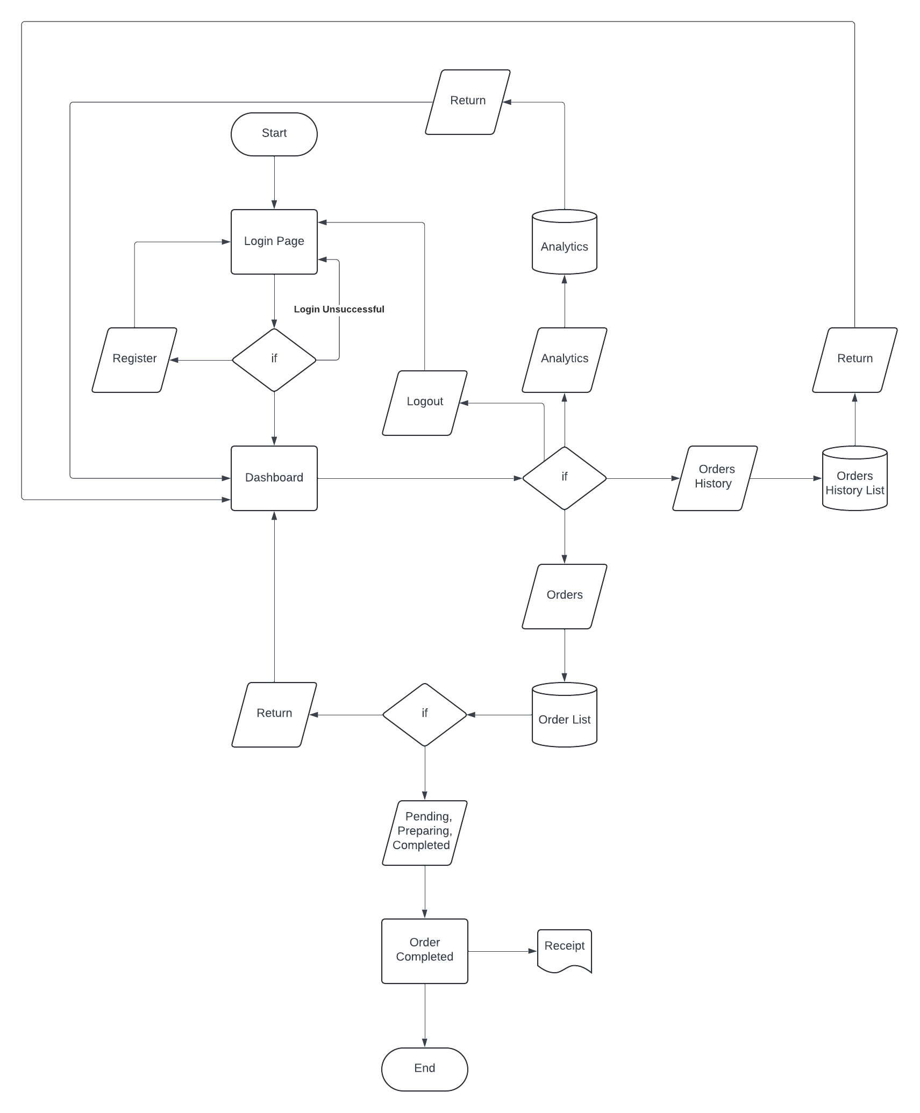

**2.1.2 Design**

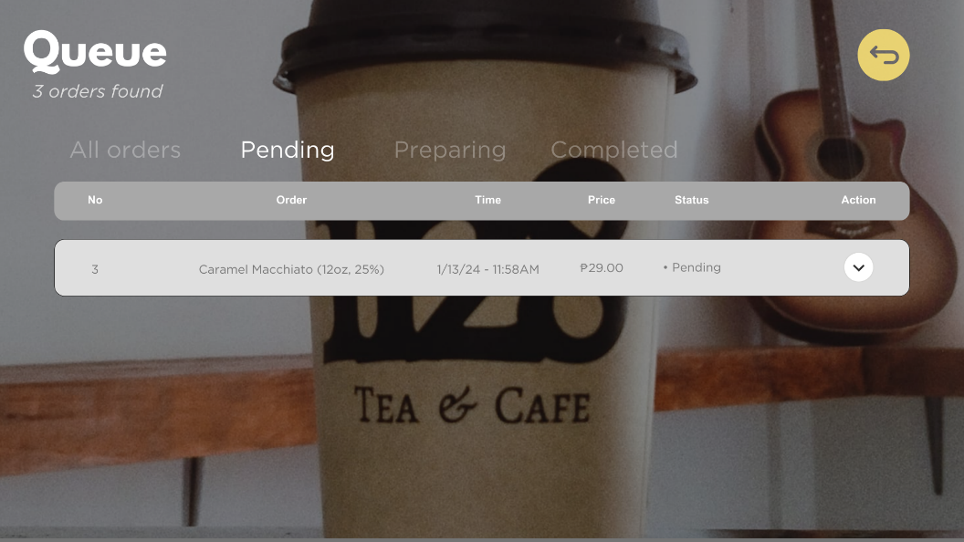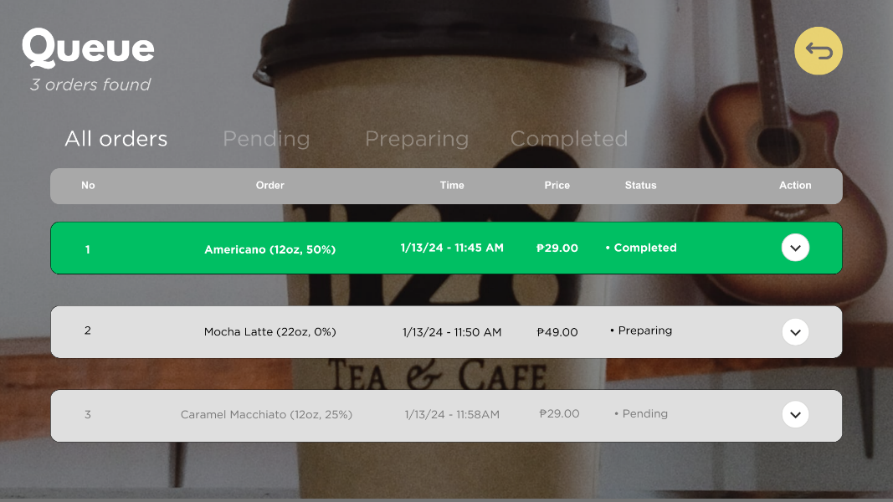

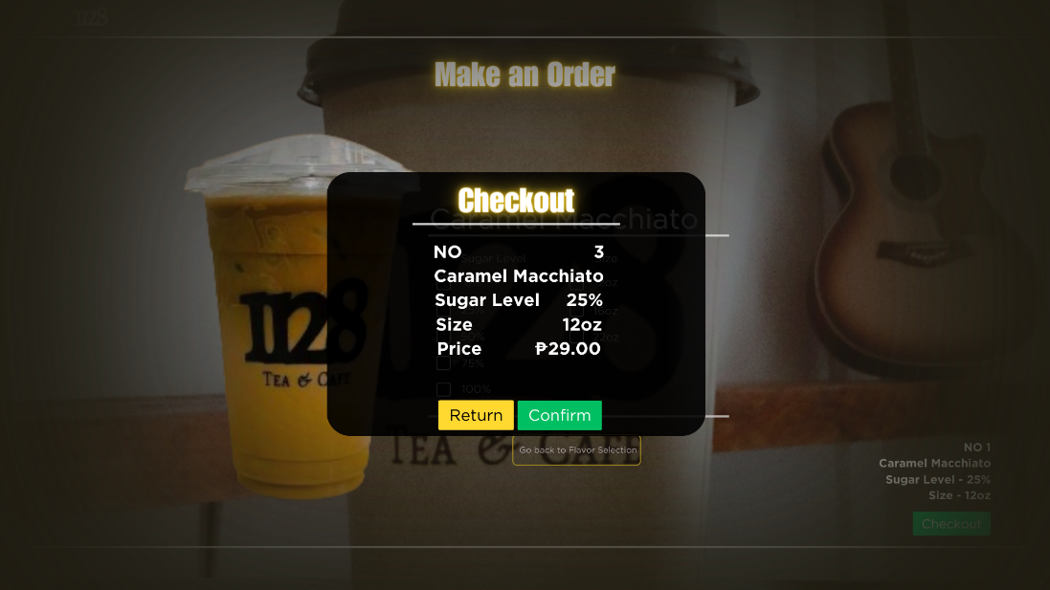

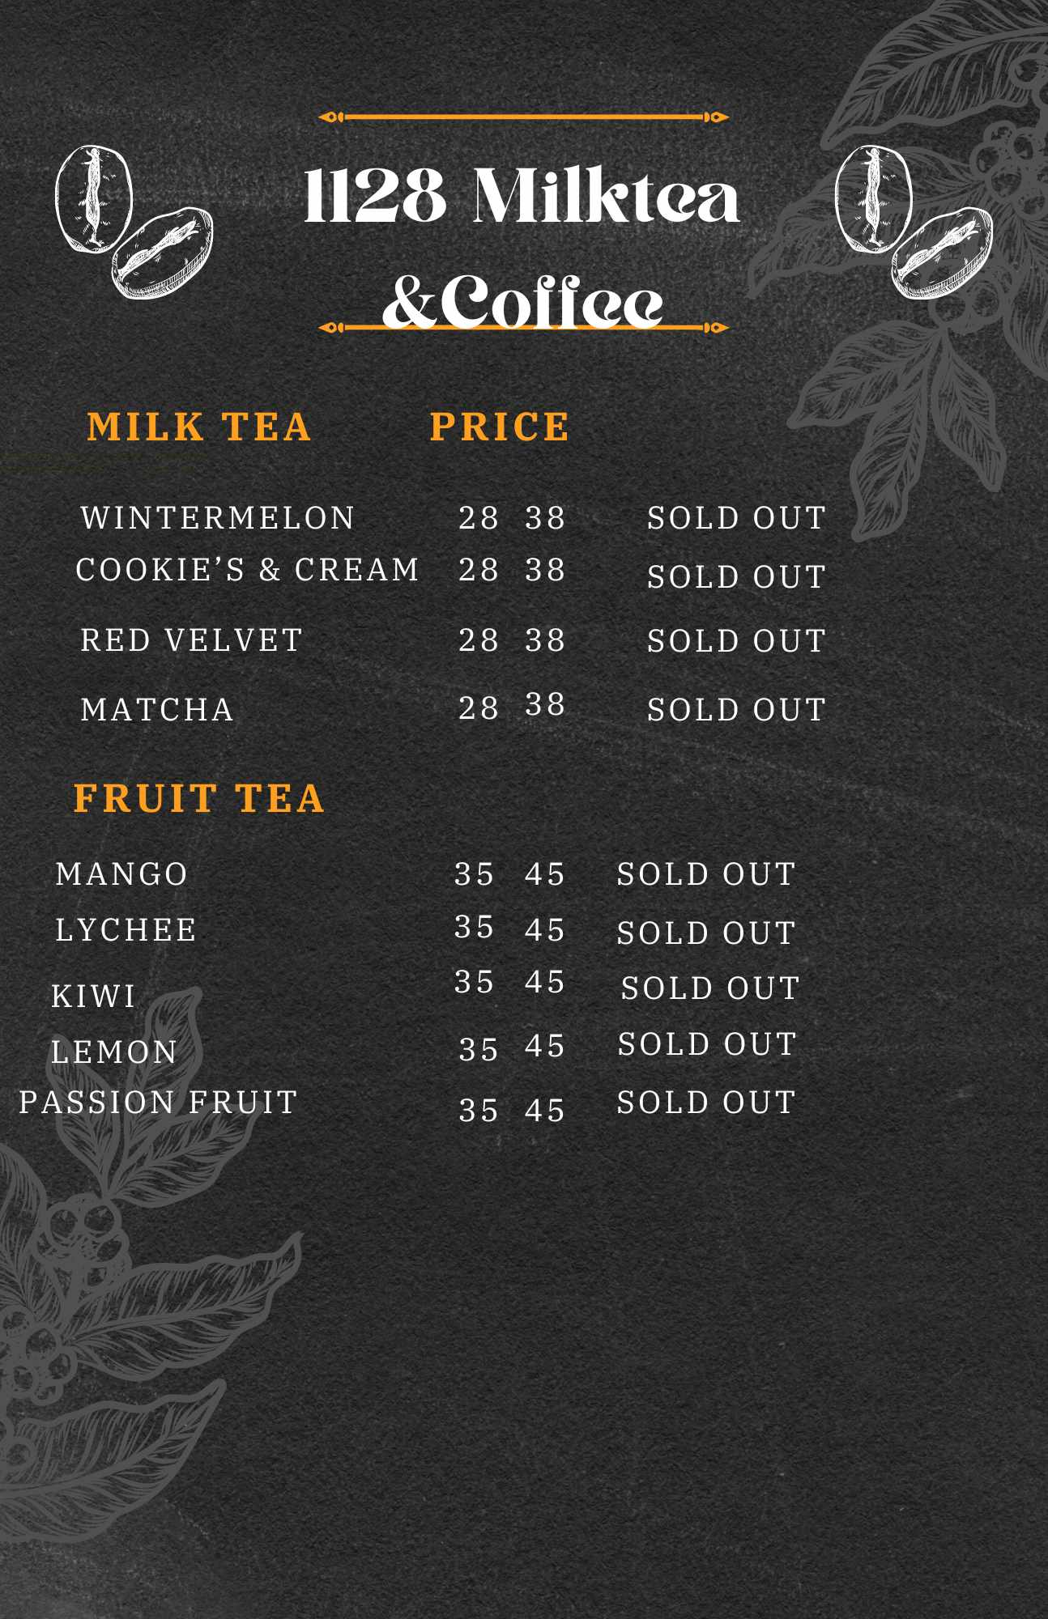



**2.2 PROJECT / SYSTEM REQUIREMENTS**

**2.2.1.1 Plagiarism**

It is the act using someone else’s ideas, words, or work without giving proper credit or permission.

**2.2.1.2 Billing and Payments**

This policy defines the terms and conditions related to invoicing, payments, due dates, late fees, refunds, and other relevant financial matters.

**2.2.1.3 Customer Service**

The customer service is a policy that should outline expectations for staff interactions with customers, including greeting the costumers, taking orders accurately and handling complaints professionally.

**2.2.2 Security Requirements**

**2.2.2.1 Customers Privacy**

It is a protections of an individual personal information and data that is collected, stored, and processed by businesses during the interactions with the customers.

**2.2.2.2 Emergency Preparedness and Response**

It is refers to the measure taken to prepare for and respond to emergency or natural disasters such as hurricanes, earthquake, and wildfires.

**2.2.1.3 Cash Handling**

The proper cash handling it is procedures that are essential to ensure the security of funds and maintain the accurate financial records.

**2.2.1.4 Terms & Conditions**

It is a set of rules that contains guidelines that users must agree to follow by in order to use a service or product.

**2.2.3 Training Requirements**

**2.2.3.1 Onboarding Training**

The new employees typically undergo onboarding training to familiarize themselves with the shop policies, procedures, and culture.

**2.2.3.2 Guidelines**

It is established to provide direction, recommendations, or instructions on how to accomplish a task, make a decision, or achieve a specific goal.

**2.2.3.3 Sales Techniques**

It is focusing on building a relationship with the customer, understanding their needs, and providing tailored solutions to meet those needs and guiding the customer towards making decision that aligns with their specific requirements.

**2.2.3.4 Safety Training**

It refers to the training program for employees to learn about procedures and practice their applications to manage risk.

**2.2.4 Reporting Requirements**

**2.2.4.1 Feedback**

It is information about reactions to a product or a person’s performance of a task, which is help used as a basis for improvement.

**2.2.4.2 Sales Reports**

It provides an overview of a company’s sales performance over a specific period and it help assess the effectiveness of the sales strategies employed.

**2.2.4.3 Customer Reports**

It is a tool for businesses to gather feedback, insights, and suggestion from the customer.

**CHAPTER 3**

**TEST RESULTS AND DISCUSSIONS**

**3.1 TEST RESULTS AND DISCUSSION**

|  |  |
| --- | --- |
| **Test Case** | **Login.** |
| **Objective** | **The user’s can access the homepage.** |
| **Test Data** | **Username and Password.** |
| **Expected Test Result** | **To successfully access the home page.** |
| **Actual Test Result** | **The use of digital platform customer and admin need to register there account in the login form they require username and password to access the homepage and various database.** |
| **Conclusion** | **The login maintain of an database of the user’s in addition to successfully access the homepage to purchase some products from the shopping site.** |

**Table #: Test Case 1**

**3.2 TEST RESULTS AND DISCUSSION**

|  |  |
| --- | --- |
| **Test Case** | **Homepage** |
| **Objective** | To serve as a table of contents for the site. |
| **Test Data** | **Dashboard** |
| **Expected Test Result** | **To display various data of an product from the shopping site.** |
| **Actual Test Result** |  |
| **Conclusion** |  |

**Table #: Test Case 2**

**3.3 TEST RESULTS AND DISCUSSION**

|  |  |
| --- | --- |
| **Test Case** | **Menu** |
| **Objective** |  |
| **Test Data** | **Product** |
| **Expected Test Result** |  |
| **Actual Test Result** |  |
| **Conclusion** |  |

**Table #: Test Case 3**

**3.4 TEST RESULTS AND DISCUSSION**

|  |  |
| --- | --- |
| **Test Case** | **Flavor selection** |
| **Objective** |  |
| **Test Data** |  |
| **Expected Test Result** |  |
| **Actual Test Result** |  |
| **Conclusion** |  |

**Table #: Test Case 4**

**3.5 TEST RESULTS AND DISCUSSION**

|  |  |
| --- | --- |
| **Test Case** | **Make an order** |
| **Objective** |  |
| **Test Data** |  |
| **Expected Test Result** |  |
| **Actual Test Result** |  |
| **Conclusion** |  |

**Table #: Test Case 5**

**3.6 TEST RESULTS AND DISCUSSION**

|  |  |
| --- | --- |
| **Test Case** | **Checkout** |
| **Objective** |  |
| **Test Data** |  |
| **Expected Test Result** |  |
| **Actual Test Result** |  |
| **Conclusion** |  |

**Table #: Test Case 6**

**3.7 TEST RESULTS AND DISCUSSION**

|  |  |
| --- | --- |
| **Test Case** | **Order complete** |
| **Objective** |  |
| **Test Data** |  |
| **Expected Test Result** |  |
| **Actual Test Result** |  |
| **Conclusion** |  |

**Table #: Test Case 7**

**CHAPTER 4**

**CONCLUSION AND RECOMMENDATION**

**4.1 Conclusion**

Our hardware and web-based solutions make it simple for clients to buy foods from the 1128 Tea & Cafe Store. The customer has the ability to choose whether to pay using digital payment or pay physically from the shop. This gives clients a shopping experience in addition to save them time, Customers can take advantage of several service by using our application. Such as ordering and purchasing straight from their devices, This removes the need to stand in or find your way around a busy store. to improve their purchasing experience. Customers can also benefit from deals and recommendations that are specifically catered to their interest. The platform provides clients with the opportunity to visit the store if they prefer the hand to hand purchasing experience.

**4.2 Recommendation**

The researchers recommended how to facilitate the customer's purchase of their product, they created an online platform and improved the image of their business which is 1128 Cafe & Tea. They also have free delivery for their customers so that going to their store is not difficult and there is an addition that when you buy one of their products you get a free product from them. the researchers improved the menu list of 1128 cafes & tea as well as their inventory, the researchers made a way how the manager can save money by listing the products that are still available so as not to double the purchased ingredients. It is also necessary to list how much they spend as well as what they earn from their business so that everyone knows how much profit their business makes.

**APPENDICES**